#### On-The-Job Training Practicum 1 Portfolio at 8Con Academy

A Practicum Portfolio

Presented to the Faculty of the Computer Science Department College of Mary Immaculate

In Partial Fulfillment

of the Requirements for Practicum 1 Bachelor of Science in Computer Science (BSCS)

Submitted By: Padilla, Jet E.

# ACKNOWLEDGEMENTS

First of all, I would like to give thanks to the Lord Almighty for guiding me and granting me the strength, wisdom, and patience I needed throughout my On-the-Job Training. His guidance enabled me to carry out my duties and responsibilities in the company.

I am truly grateful to 8Con Academy for welcoming me as part of their team. My heartfelt thanks go to my supervisor, **Dr. Mayette L. Francisco**, for her valuable guidance, constructive feedback, and encouragement during my training. I also extend my gratitude to the president of 8Con Academy, **Sir Jim Francisco**, for imparting important lessons in both FOREX trading and life that I will carry with me as I move forward.

To my fellow workmates, especially Batch 1 at 8Con Academy, thank you for the warm welcome, the support, and the knowledge you shared with me, all of which have greatly contributed to my personal and professional growth.

I am also sincerely thankful to my OJT Coordinator and instructor, **Mr. Joseph Bernard Reyes, DEM**, of the College of Mary Immaculate of Pandi, Bulacan, for his guidance and preparation that equipped me with the skills I needed to succeed during this training.

# Table of Contents

1. Abstract 4
2. Memorandum of Agreement 5
3. Endorsement Letter 8
4. Intent Letter 9
5. Old Resume 10
6. Daily Journal 12
7. Daily Time Record 33
8. Certificate of Completion 35
9. Updated Resume 36
10. Application Letter 39
11. Projects 40
12. Narrative Experience 42
13. Conclusion 44
14. Photo Collage 45

# ABSTRACT

This portfolio highlights my On-the-Job Training (OJT) experience at **8Con Academy**, where I took on the role of **Team Leader of the Marketing Department** before the arrival of the 3rd batch of OJT trainees, from **April 28, 2025 to June 09, 2025**. It showcases the skills I developed, the projects and tasks I accomplished, and the experiences I gained, reflecting how I applied my academic learning in a professional environment.

Included in this portfolio are key documents such as my **Memorandum of Agreement (MOA), endorsement letter, letter of intent, previous resume, daily journal, daily time record (DTR), certificate of completion (COC), updated resume, and a sample application letter**. I also present my narrative experience and a concluding reflection on the knowledge and skills I acquired throughout my training.

This portfolio also details my **daily responsibilities, projects, skills enhanced, and personal reflections** on the challenges I encountered and the milestones I achieved. Collectively, these demonstrate my **professional growth, improved communication and skills, stronger teamwork, and adaptability to a dynamic workplace environment**.

.

# MEMORANDUM OF AGREEMENT

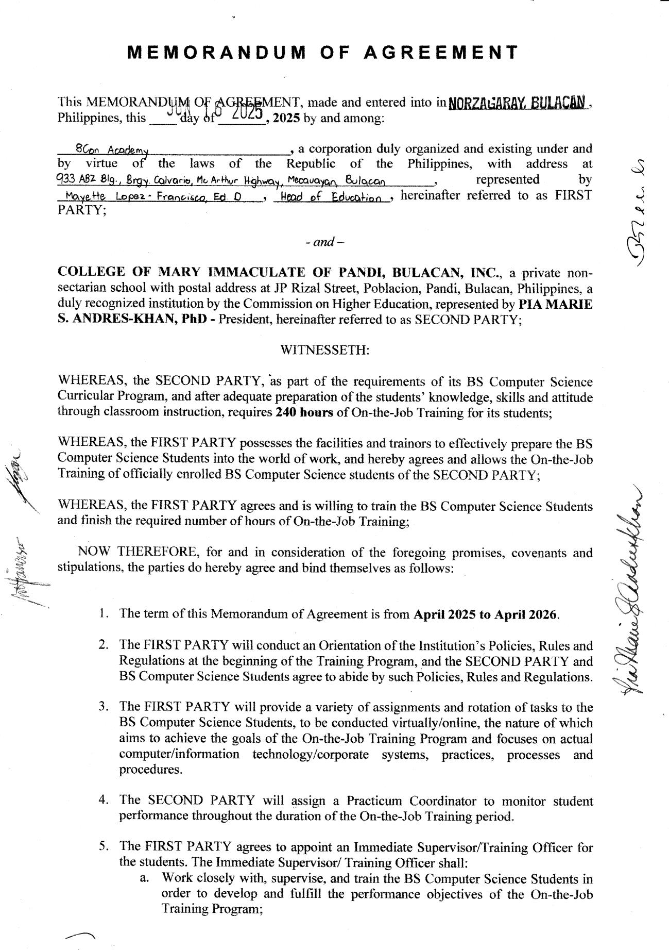

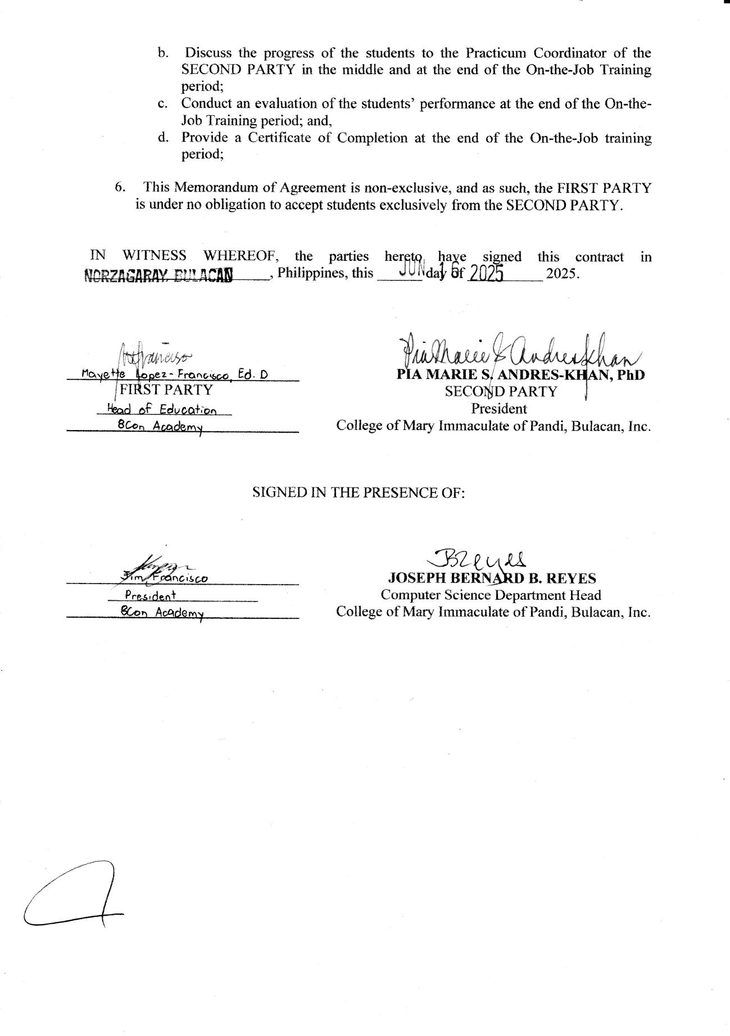

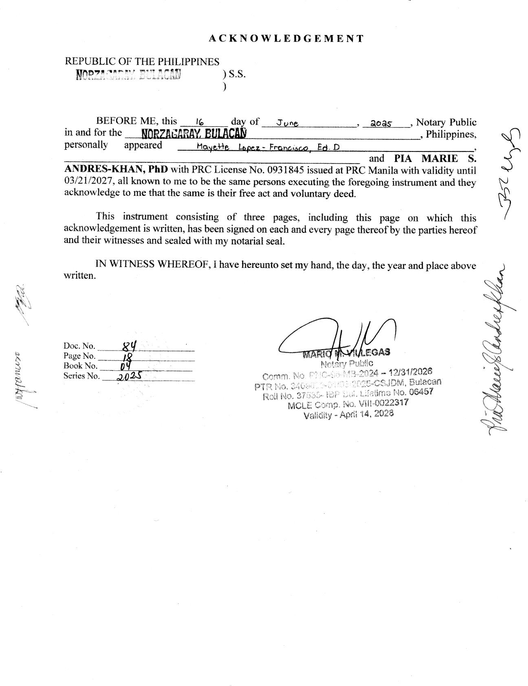

# ENDORSEMENT LETTER

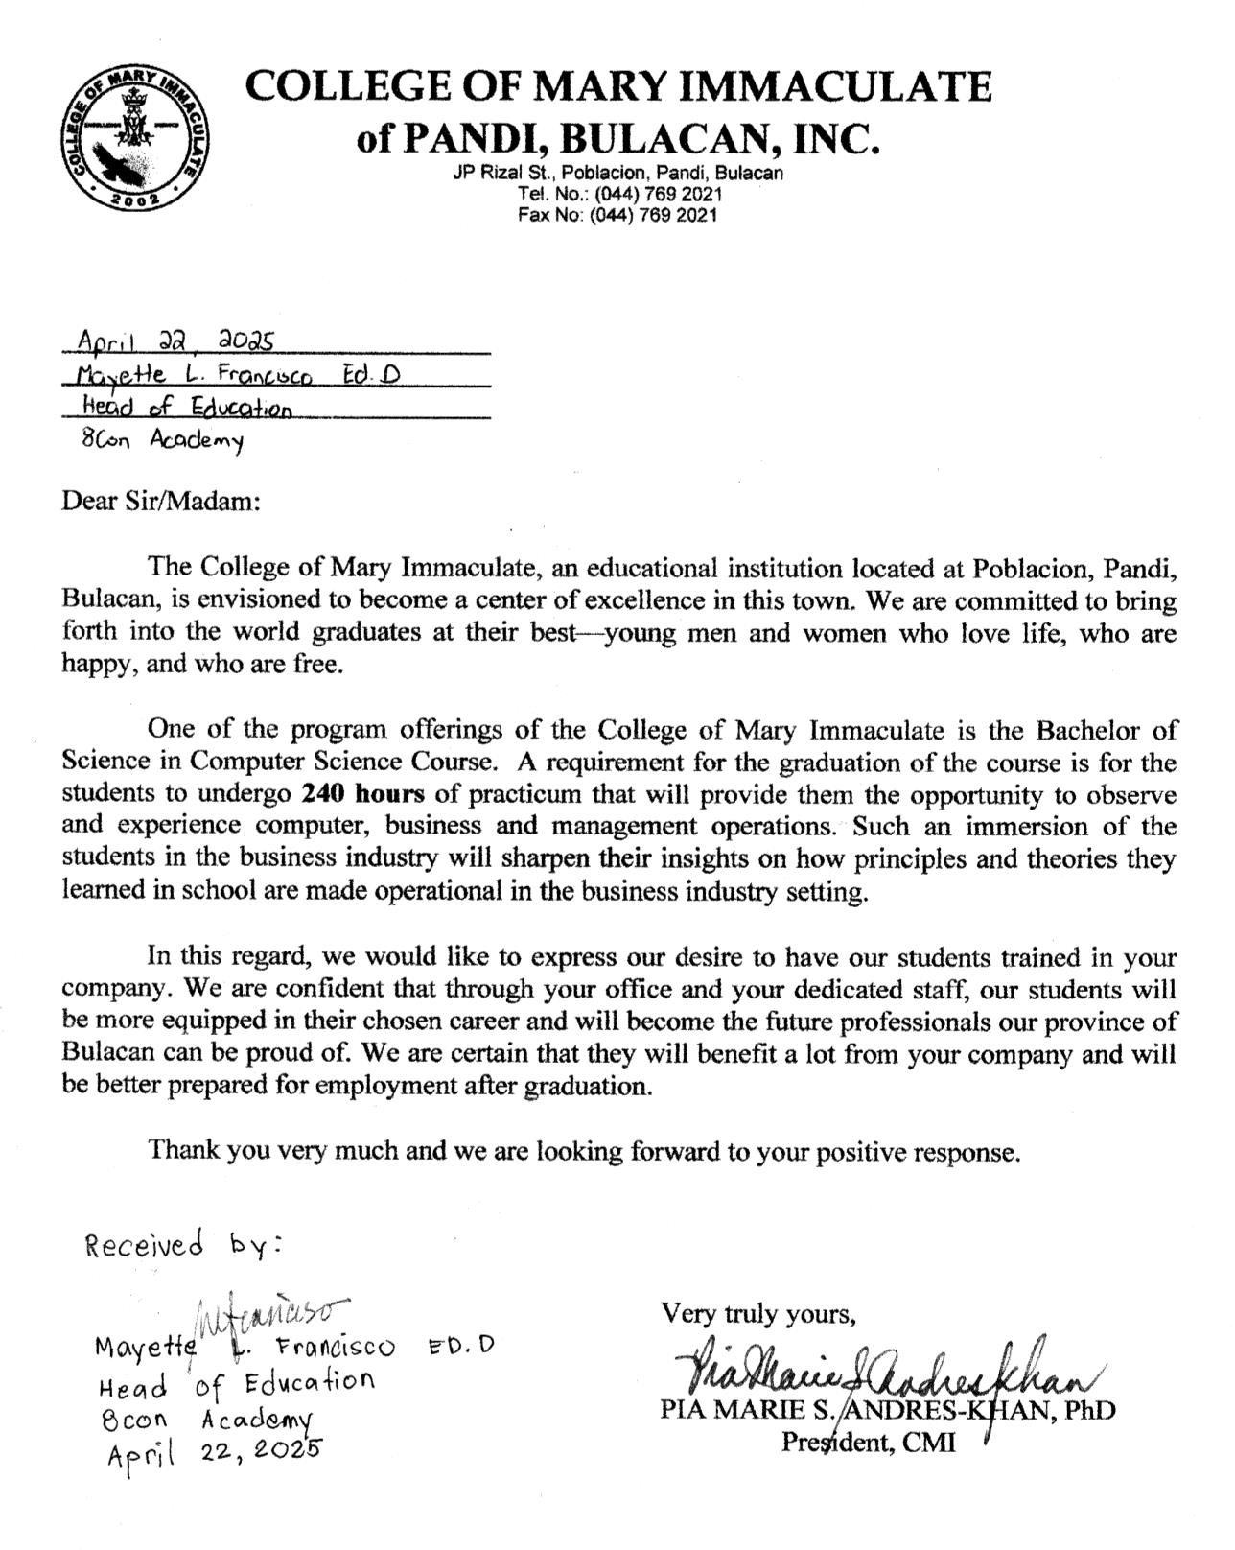

# INTENT LETTER

Jet Padilla

Padre Pio, Cacarong Bata

Pandi, Bulacan

Jetpadilla07@gmail.com

(+63)-9155480755

April 28, 2025

Dr. Mayette L. Francisco, Ed.D Head of Education

8Con Academy

933 ABZ Building, Brgy. Calvario, MacArthur Highway Meycauayan, Bulacan

Dear Dr. Francisco,

I hope this letter finds you well. I am writing to formally express my intent to undergo On-the-Job Training (OJT) at 8Con Academy. I am a student of Bachelor of Science in Computer Science at College of Mary Immaculate of Pandi, Bulacan Inc. and I am honored to have been accepted for training in your esteemed organization. I understand and acknowledge the responsibilities that come with this opportunity and I am fully committed to adhering to your institution’s policies, guidelines, and expectations throughout the duration of my training. I believe this experience will greatly contribute to both my academic development and personal growth.

Thank you very much for this opportunity. I look forward to learning for your team and contributing positively in any way I can.

Respectfully yours,

Jet Padilla

College of Mary Immaculate of Pandi, Bulacan Inc.

# OLD RESUME

# 

# DAILY JOURNAL

**OJT JOURNAL**

**WEEK 1**

Student Name: **Jet Padilla**

Year and Course: **BSCS - 3**

Company: **8Con Academy**

|  |  |  |  |  |
| --- | --- | --- | --- | --- |
| **Date** | **Specific Task** | **Challenges** | **Learnings** | **Documentation** |
| April 28, 2025 (Monday) | Orientation and introduction to company policies. Set up work environment and tools  (Canva, Email Access, Meta Business Suite) | Getting familiar with the new work environment and understanding expectations. | Gained understanding of company structure, tools used, and workflow processes,  Successfully adapted. |  |
| April 29, 2025 (Tuesday) | Observed project management tools in use, assisted in minor tasks like updating documentation. | Difficulty understanding some technical terms and project tools at first. | Learned basic functionality of project management platforms and importance of clear documentation. |  |
| April 30,  2025  (Wednesday) | Assigned a small task like scheduling posters and editing raw media | Difficulty about thinking new captions for the posters | Learned from mentor feedback. |  |
| May 2,  2025  (Friday) | Scheduling and tried to make an auto scheduling using python, HTML, CSS | Time management balancing assigned tasks with learning new project | Understood the value of constructive project standards or content style. |  |
| May 3,  2025  (Saturday) | Assisted in organizing and managing a company workshop. Assigned as the event photographer and documentation officer. Captured photos, documented activities, and helped facilitate attendees. | Managing time while multitasking between assisting participants and capturing key moments. Ensuring photo quality in varying lighting conditions. | Learned how to manage responsibilities in a live event setting, improved photography and documentation skills, and gained confidence in handling real-time tasks during public activities. |  |

**Prepared By: Reviewed By:**

Padilla, Jet Joseph Bernard Reyes  
Intern BSCS Head

**OJT JOURNAL**

**WEEK 2**

Student Name: **Jet Padilla**

Year and Course: **BSCS - 3**

Company: **8Con Academy**

|  |  |  |  |  |
| --- | --- | --- | --- | --- |
| **Date** | **Specific Task** | **Challenges** | **Learnings** | **Documentation** |
| May 5, 2025 (Monday) | Getting familiar with GHL | GHL offers a lot of tools and automation features, which initially felt overwhelming. It took time to understand how everything connects, like how workflows trigger certain actions and how different modules, such as forms and opportunities, are linked. | I became more comfortable navigating the platform and learned how its parts work together to streamline business processes. |  |
| May 6, 2025 (Tuesday) | GHL Funnel Site Activity (Front end) | I had trouble figuring out the front-end editor adjusting spacing, alignment, responsiveness, and ensuring consistent design across the funnel steps needed careful attention. | I learned to use GHL’s funnel builder to design landing pages, edit text, images, buttons, and forms. This also improved my confidence in using front-end tools within GHL. |  |
| May 7,  2025  (Wednesday) | Tested automation features in GHL, focusing on Conversations and Workflows. | Some automated actions weren’t triggering properly, so I had to carefully review conditions, triggers, and conversation setups to make sure everything was timed and linked correctly. | I learned to set up workflows, add auto-replies in Conversations, and assign contacts to the right stages in the pipeline. |  |
| May 8,  2025  (Thursday) | GHL Funnel Site Activity (Back end) | Ensuring form submissions correctly triggered workflows and sent data to the right contact records and pipelines took extra effort. | I learned how to connect forms to workflows, manage funnel steps, and ensure smooth data transfer between funnel stages. |  |
| May 9,  2025  (Friday) | FOREX Training (Day 4) | It was hard to fully keep up with the session since I don’t yet have an address certification to create a Tickmill account. | Even with that challenge, I still picked up valuable insights about market behavior and risk management in Forex. |  |

**Prepared By: Reviewed By:**

Padilla, Jet Joseph Bernard Reyes  
Intern BSCS Head

**OJT JOURNAL**

**WEEK 3**

Student Name: **Jet Padilla**

Year and Course: **BSCS - 3**

Company: **8Con Academy**

|  |  |  |  |  |
| --- | --- | --- | --- | --- |
| **Date** | **Specific Task** | **Challenges** | **Learnings** | **Documentation** |
| May 13, 2025 (Tuesday) | Explored GoHighLevel (GHL) funnel builder. | Familiarizing with the GHL funnel interface and components. | Gained hands-on experience building funnels in GHL. |  |
| May 14, 2025 (Wednesday) | Created a **Graduation Eligibility Checker**  Edited **meme videos** using **Canva** for the first time  Saved **editable templates** for company-wide reuse | Structuring eligibility logic and user-friendly design for the checker  Navigating Canva’s video timeline and layers as a first-time user  Ensuring the saved templates are editable and reusable by other team members | Learned how to apply conditional logic for eligibility display  Gained experience with **Canva's video editing tools**  Understood best practices for preparing reusable brand templates |  |
| May 15, 2025  (Thursday)  May 16,  2025  (Friday) | Revised the **Graduation Eligibility Checker** design in **Figma**.  Edited a promotional video featuring **Sir Jim** and **Tickmill** together. | Aligning the layout to be both clean and intuitive while making sure all key data points (student name, ID, and graduation status) were clearly visible.  Syncing dialogue and visuals to maintain a smooth flow throughout the video.  Ensuring branding elements and  transitions matched the company’s visual style.  Managing audio levels and clarity, especially in combining clips from different sources. | Gained experience with component grouping and consistency in Figma for smoother design handoffs.  Enhanced skills in video sequencing and storytelling using editing tools.  Gained better understanding of |  |

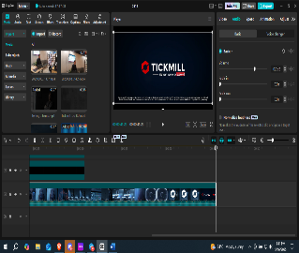

**Prepared By: Reviewed By:**

Padilla, Jet Joseph Bernard Reyes  
Intern BSCS Head

**OJT JOURNAL**

**WEEK 4**

Student Name: **Jet Padilla**

Year and Course: **BSCS - 3**

Company: **8Con Academy**

|  |  |  |  |  |
| --- | --- | --- | --- | --- |
| **Date** | **Specific Task** | **Challenges** | **Learnings** | **Documentation** |
| May 19, 2025 (Monday) | Started building the **Graduation Eligibility Checker** using **static HTML/CSS**. | Initially attempted to integrate it directly into the **SPA (Single Page Application)** setup, which caused a lot of stress and confusion due to the complexity.  Faced issues with routing and component rendering within the SPA structure. | Realized the importance of breaking down tasks starting with a static version helped simplify and clarify the overall logic. |  |
| May 20, 2025  (Tuesday) | Edited the **revised version** of the video from **May 16 (Friday)** featuring **Sir Jim and Tickmill**.  Fine-tuned the visuals, transitions, and synced the audio for a smoother flow. | Ensuring the revised edits aligned with branding and message tone.  Experienced eye strain during the editing process, which made it harder to focus and slowed down progress. | Realized the importance of proper screen time management and rest during intense editing sessions. |  |
| May 21, 2025  (Wednesday) | Scheduled the FYI posters for 8Con on the official platforms. | Ensured the posters were correctly timed and aligned with upcoming announcements or events. | Gained more familiarity with scheduling tools and workflow processes. |  |
| May 22, 2025  (Thursday) | Posted one of the meme videos I created the day before on the 8Con Academy page. | Ensuring the timing, caption, and relevance of the post aligned with the brand’s tone and current audience engagement. | Learned how humor and relatability can boost engagement. Also observed how meme-style content can be a powerful way to humanize the brand and connect with our community. |  |
| May 23, 2025  (Friday) | Scheduled the meme videos I created earlier for posting on the company page.  Assisted my teammate in new posting schedules. | Balancing my own tasks while helping my teammate manage their posting queue. | Practiced teamwork and communication in coordinating tasks within the content team. |  |

**Prepared By: Reviewed By:**

Jet Padilla Joseph Bernard Reyes  
Intern BSCS Head

**OJT JOURNAL**

**WEEK 5**

Student Name: **Jet Padilla**

Year and Course: **BSCS - 3**

Company: **8Con Academy**

|  |  |  |  |  |
| --- | --- | --- | --- | --- |
| **Date** | **Specific Task** | **Challenges** | **Learnings** | **Documentation** |
| May 26, 2025 (Monday) | Created and edited a meme video  Integrated the video into the Canva meme video template  Wrote a caption and generated relevant hashtags for social media posting | Improved workflow efficiency using Canva templates  Practiced creativity in aligning captions and visuals for better engagement | Fine-tuning text timing and position for clarity on different screen sizes  Ensuring caption tone stayed consistent with the brand |  |
| May 27, 2025  (Tuesday) | Scheduled the meme videos saved from Canva for Sunday posting  Organized content in advance to maintain consistent engagement | Practiced organizing posts for a balanced content calendar | Matching meme timing with audience activity for better reach |  |
| May 28, 2025  (Wednesday) | Drafted the layout and structure for the career paths presentation using Canva.  Designed the initial visual slides based on the 9 potential paths for graduates. | Condensing detailed information into minimal, easy-to-digest slide formats.  Balancing aesthetics with clarity and information density. | Learned better slide organization techniques for professional content. |  |
| May 29, 2025  (Thursday) | Completed the design and proofreading of the Canva presentation.  Uploaded and scheduled the "Career Paths After 8Con Academy Graduation" post for Facebook as an FYI content. | Fine-tuning final designs while maintaining consistency across slides.  Scheduling content at an optimal posting time for reach and engagement. | Learned how to prepare and automate posting using Facebook’s scheduling tools.  Gained more confidence in presenting educational information via visual content. |  |
| May 30, 2025  (Friday) | Created multiple meme video edits using the Canva meme video template for 8Con. | Selecting the most engaging clips that match the meme format. | Improved speed and creativity using Canva’s video tools. |  |
| May 31, 2025  (Saturday) | Briefed the new OJTs about documentation responsibilities for the workshop.  Guided and supported them in improving their documentation and content-gathering skills. | Balancing between giving guidance and letting them work independently. | Learned how to effectively communicate expectations to new team members.  Gained appreciation for the OJTs’ initiative and quality of work. |  |

**Prepared By: Reviewed By:**

Jet Padilla Joseph Bernard Reyes  
Intern BSCS Head

**OJT JOURNAL**

**WEEK 6**

Student Name: **Jet Padilla**

Year and Course: **BSCS - 3**

Company: **8Con Academy**

|  |  |  |  |  |
| --- | --- | --- | --- | --- |
| **Date** | **Specific Task** | **Challenges** | **Learnings** | **Documentation** |
| June 2, 2025 (Monday) | Connected the **“Add New Account”** page to the API so that it can now successfully add new accounts to the database/system. | Initially found it difficult because I had no prior experience with API integration. I struggled with how to send data properly and how endpoints interact with the frontend form. | I adapted quickly thanks to the guidance of **Michael Ponce**, who helped explain how the process works. I learned how to connect frontend forms to backend APIs, structure payloads, and handle responses, which gave me a better understanding of full-stack development. |  |
| June 3, 2025  (Tuesday) | After completing the “Add New Account” feature, I started working on displaying the newly added accounts in the **Account Management** section. Since the API didn’t exist yet, I created the necessary **routes, models, and controllers** for it. | It was quite difficult to connect everything as I was still figuring out how APIs work.  Understanding how data flows between the frontend and backend took time. | Despite the challenge, I managed to build and set up the API from scratch. This gave me hands-on experience in setting up the backend side of a feature using MVC structure, and it helped me become more confident in working with APIs and connecting them to the frontend. |  |

|  |  |  |  |  |
| --- | --- | --- | --- | --- |
| June 5,  2025 (Thursday) | Began Transitioning tasks related to the EAST project to the new Batch | One challenge was clearly explaining the current progress and technical details in a way that’s easy for the new batch to understand. I had to simplify some parts without leaving out important information. It also took time to make sure all the necessary files, notes, and access were properly handed over. | I learned how important it is to communicate clearly when handing off responsibilities. This experience helped me improve how I organize project information and consider what others need to know when taking over a task. It also reminded me how teamwork depends on smooth transitions. |  |
| June 7,  2025  (Saturday) | Forex Workshop | I didn’t encounter any major challenger during this task | I gained personal insights through the team leaders of each batch especially in mentoring and collaboration it was the last day at the 8con Academy |  |

**Prepared By: Reviewed By:**

Jet Padilla Joseph Bernard Reyes  
Intern BSCS Head

# DAILY TIME RECORD

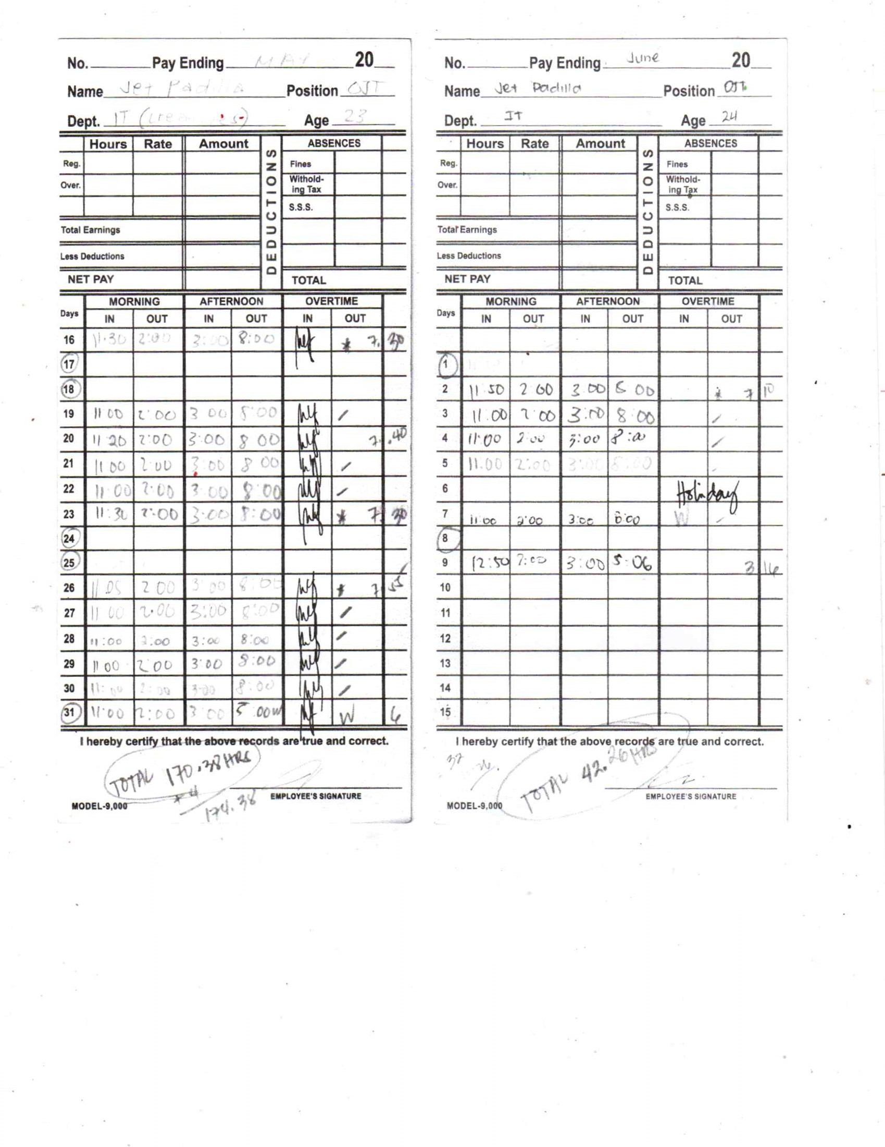

# CERTIFICATE OF COMPLETION

# UPDATED RESUME

# Jet Escartin Padilla

# Phone: 0915-548-0755 Email: jetpadilla07@gmail.com Location: Pandi, Bulacan GitHub: github.com/nahiwagaan Portfolio: nahiwagaan.github.io LinkedIn: https://www.linkedin.com/in/jet-padilla-b19b68327/

# Professional Summary

# An aspiring web developer who seeks to craft intuitive, visually appealing, and user-friendly web experiences by combining creativity with technical expertise, staying updated with the latest industry trends, and continuously refining skills to deliver impactful digital solutions.

# Education

# Bachelor of Science in Computer Science College of Mary Immaculate 2023 - Present

# Relevant Experience

# Intern - Web Developer

# EASTS - Enrollment System

# Enrollment management platform designed for EASTS 8CON Academy to streamline student registration, class scheduling, and academic record tracking. The system supports both administrator and student portals, allowing easy course enrollment, profile management, and progress monitoring.

# Projects

# CONEXUS - Social Media Platform

# Developed a SPA social media platform with user profiles, posts, comments, and likes

# Built a RESTful API in Node.js/Express.js for authentication, post management, and real-time updates

# JENATHER CAR DEALERSHIP - E-Commerce

# Built frontend with HTML/CSS and used MySQL for product data, user auth, and orders

# Secured admin authentication for managing products and restricting unauthorized access

# Additional Projects

# File Organizer (Python)

# Auto Backup (Python)

# The New York Times (Website)

# Portfolio (Website)

# Minute Lotto (Website)

# Relevant Skills

# Programming Languages & Technologies

# Python

# HTML/CSS

# JavaScript

# Tools & Technologies

# Figma

# Database Management

# Computer Skills

# Character Reference

# Jober Reyes ollege of Mary Immaculate Phone: 09922346806

# APPLICATION LETTER

**JET E. PADILLA**

**jetpadilla07@gmail.com | 0915-548-0755 Cacarong Bata, Pandi Bulacan.**

**September 19, 2025**

KDCI Outsourcing Pasig City, Metro Manila

Outsourcing and Offshoring

Consulting

Dear KDCI Outsourcing,

I’m excited to apply for the Web Graphic Designer role at KDCI Outsourcing. I’m currently in my fourth year of studying Computer Science at the College of Mary Immaculate, and over the past few years I’ve built a strong background in web development and design. I enjoy finding the balance between creativity and technical detail, and I’d love the chance to bring that approach to your team. Most of my experience is in frontend development, though I’ve also worked with backend tools like JavaScript, PHP, and MySQL. One project I’m especially proud of was when my team built a Threads clone. I focused on the user interface, making sure the layouts were clean, responsive, and easy to use, while also helping set up user authentication and database connections on the backend. It taught me how design and function need to work together to deliver a good product. I’d love the opportunity to bring both my creative eye and technical skills to KDCI. Thank you for taking the time to review my application. I’d be happy to discuss how I can contribute to your projects, and I’m available for an interview whenever it’s convenient.



Sincerely,

**Jet E. Padilla**

# PROJECTS

## 8CON EASTS

* + Designed and develop a prototype for an onsite enrollment system aimed at streamlining student management and course management for 8Con Academy.
  + Contributed to the planning and testing phases.
  + The technologies used in this project are HTML, CSS, JavaScript for front-end and Node.js for back-end.
  + The features implemented includes student data entry, user authentication, competency assessment, and filtering the records of the student. This features are in the initial plan for the development.
  + We successfully presented the early prototype to the president of the company for initial feedback, laying groundwork for further improvements of the system and potential scaling development.

## 8CON Sales Funnel Development

* + Contributed to the development of a sales funnel system designed to improve management and conversion processes for 8Con Academy.

# XI. NARRATIVE EXPERIENCE

When I first went to OJT, I was so amazed by the things. I was in culture shock by the time they taught us the funnel and GHL or wordpress, because I had no experience there, all I knew was vanilla programming. I survived and had fun because I learned the things I hadn't learned yet, in the first week I was pretty familiar with what I would do in marketing since I was assigned to lead marketing. In the second week I gradually applied everything we were doing through with the help of my co-workers in designing flyers and posters that I scheduled on Facebook. In the third week I had experience editing promotional videos so that more people would engage with the videos we were making. In my fourth week, we planned to create an enrollment system platform so we designed an enrollment system platform in figma and my task was the graduation eligibility checker with marketing tasks as well. on my fifth week i started to develop the graduation eligibility checker by coding frontend it was a bit hard but still i perfected it. on my sixth week, i started helping in the backend developing with the API to connect to the graduation eligibility checker, it was a bit hard so i just asked my classmates to help, and we also started to pass on the tasks that new OJTs could do to our enrollment system with documented.

# XII. CONCLUSION

To conclude and summarize my intership experience at 8Con Academy, I can describe it in one word, wonderful. This experience thought me the importance of work and life balance, time management, communication. I also gained a lot of knowledge from the people that I interact with. Their perspective on work and life helped me grow in both professional and personal. Although, I didn’t expect the work environment to be like this. The atmosphere is very friendly and lively. As long as you were done with your tasks, you can take a break at the pantry or grab some snacks in the nearby stores. In addition to that, you can freely engage in communication with other OJTs. You can socialize, communicate and brainstorm with them. 8Con thought me to socialize. It thought me to take accountability for every action and decision that I make.

I am very thankful to 8Con Academy to have this kind of experience. This exeperience will be embedded to my personality and looking back in the future, I achieved this because 8Con Academy was there, helping me grow and teaching me valuable lessons that will contribute to who I am today

1. **PHOTO COLLAGE**



